Child renewal passport application - PC8 Checklist
- Completed and printed online application form
- Include 2 Australian standard passport photos - *see guidelines below
- Completed credit card authorisation payment form
- Post to your nearest Australian mission, see Department of Foreign Affairs and Trade website for location details.

Child PC8 Passport Application CHECK LIST
- Did you complete and print the form from the Australian Passport Office website?
- Did you check the current home address, contact phone number and email address on the form are valid and correct
- Are the biodata details correct on the application form? (Name, Place of Birth, Country of Birth, Date of Birth and Sex)
- Did you include a minimum of two passport photos?
- *Do the photos meet the photo guidelines
- Did the guarantor endorse the back of one photo in black ink pen?
- Did both parents include certified copies of their proof of identity showing name, photo, signature and current address?
- **Are both parents’ names the same as how they appear on the child’s birth certificate?
- Did the guarantor complete and sign section 11?
- Did both parents complete and sign section 15 (declaration and consent)?
- Did one parent (or person with parental responsibility for the applicant) sign Section 17?
- If the child is aged 10, did they sign Section 18?
- Check all signatures are within six months of mailing the application
- Check all signatures are within the signature box
- Did you complete the payment authorisation form?
- Check the form is printed in full and no parts of the form are cut short

*If you have any concerns about your photo, please check our photo guidelines or go to the next page for examples of acceptable photos.
https://www.passports.gov.au/getting-passport-how-it-works/photo-guidelines
** If the current names of either parent are different from those on the birth certificate, please include certified copies of documents that explain the change of name.

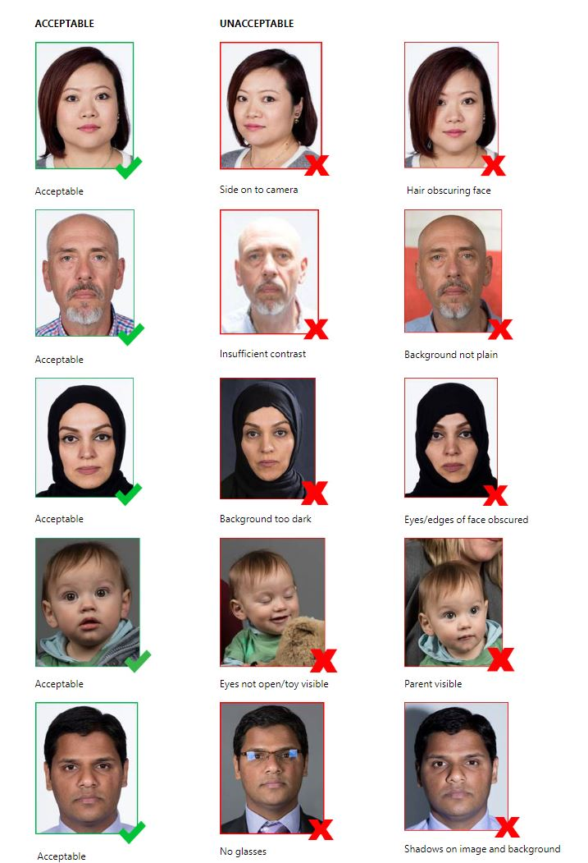
https://www.passports.gov.au/getting-passport-how-it-works/photo-guidelines

